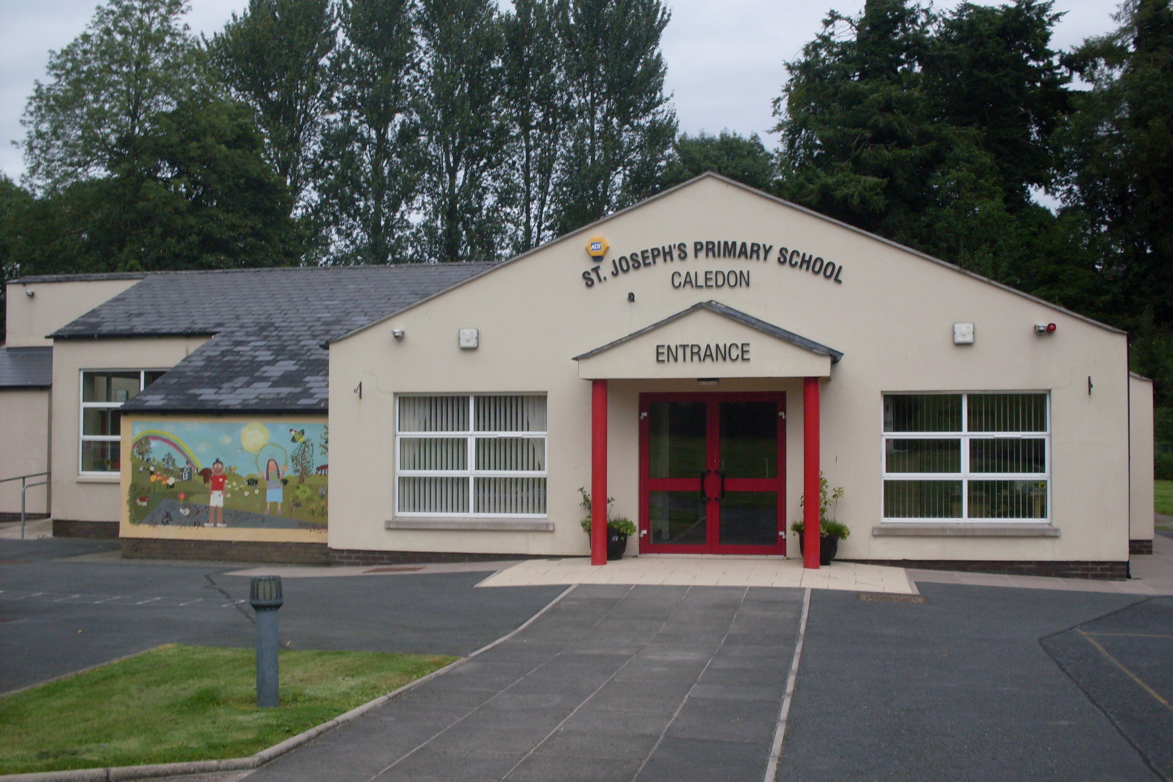

St. Joseph’s Primary School,
14, Derrycourtney Road,
Caledon,
Co. Tyrone
BT68 4UF
Tel: 37568537
Principal: Mrs Marie McKenna

St Joseph’s Primary School

Newsletter – August 2021

Dear Parents

Dates for the Diary

Date | Event
1st September | All children return to school  P1 &2 go home at 1.45pm  NB- If you wish your P1/2 child to stay to later time of 2.45pm please let us know.  P3-P7 go home at 2.45pm  NB All P1-3 children go home early on frodays @ 1.45pm

Health Check Update
We understand that children can become unwell for a variety of reasons that are not COVID related. The is to clarify the procedures on what happens if your child is unwell. We are following guidance and direction from the Department of Education, the Education Authority and the Public Health Agency. Thus it is vital that we all are aware of the following:

If your child or children appear unwell or display any of the symptoms of Covid-19 they should not be sent to school. Symptoms of Covid-19 include:-
• a high temperature – this means you feel hot to touch on your chest or back (you do not need to measure your temperature), or;
• a new, continuous cough – this means coughing a lot for more than an hour, or 3 or more coughing episodes in 24 hours (if you usually have a cough, it may be worse than usual), or;
• anosmia - the loss or a change in your normal sense of smell (it can also affect your sense of taste)
Source: https://www.nidirect.gov.uk/articles/coronavirus-covid-19-overview-and-advice

If your child becomes unwell in school, we will isolate them in Mrs Mckenna’s office ( an adult will be in sight at all times) and contact you. If you wish, with your permission, we will take your child’s temperature at this point.

The children have been so good about abiding by the hand washing rules and keeping to their ‘bubble.’ Although ‘bubbles’ are no loger manadotory, we will keep to them at present and review them at half-term. Clearly you have all played your part in preparing them for back to school and for that we are very grateful.

School Day
When children arrive at school, the P1- 4 children will come through the door at the side of Mrs McKenna’s classroom. The P5- 7 children will enter the school via the door beside Miss Largey’s classroom. Staff will be on hand to direct and help pupils. The children will immediately hang up their coat and put on their indoor shoes. BEFORE ENTERING THE CLASSROOM, THEY WILL WASH THEIR HANDS IN THE BATHROOM. Hand sanitisers will be available at all entrance/exit points. The children will remain in their class ‘bubble’ for the duration of the day.
Children will go straight to their named, dedicated seat in their classroom.
Uniform & School Bags
PE uniform is acceptable for daily wear until we review the situation at Halloween. This is to enable parents to wash uniforms frequently. Full school uniform is also acceptable, if preferred. Full school uniform will be required for special events such as photographs or a school Mass. You will be given notice in advance if it is required.
School bags are now allowed in school but must be hung on a peg outside the classroom. Children should not share any iems with others. Indoor shoes must be worn in school.
Snack Time
This comprises a slice of toast and a glass of milk or water.
Please note, your child is welcome to take fruit from home instead if they wish. However, please ensure that any fruit taken is ready for the child to eat and does not need an adult to peel or chop. This is to minimise the contact staff have with food. The cost of the snack is 50p a day or £2.50 a week.

After School for P1-2 children
After- School Club from 1.45-2.45pm will continue as usual for the P1-2 children. We are hoping to reintroduce afterschool activities for all other children as soon as possible. There is no afterschool club on a Friday

Yours sincerely,
M Mckenna

