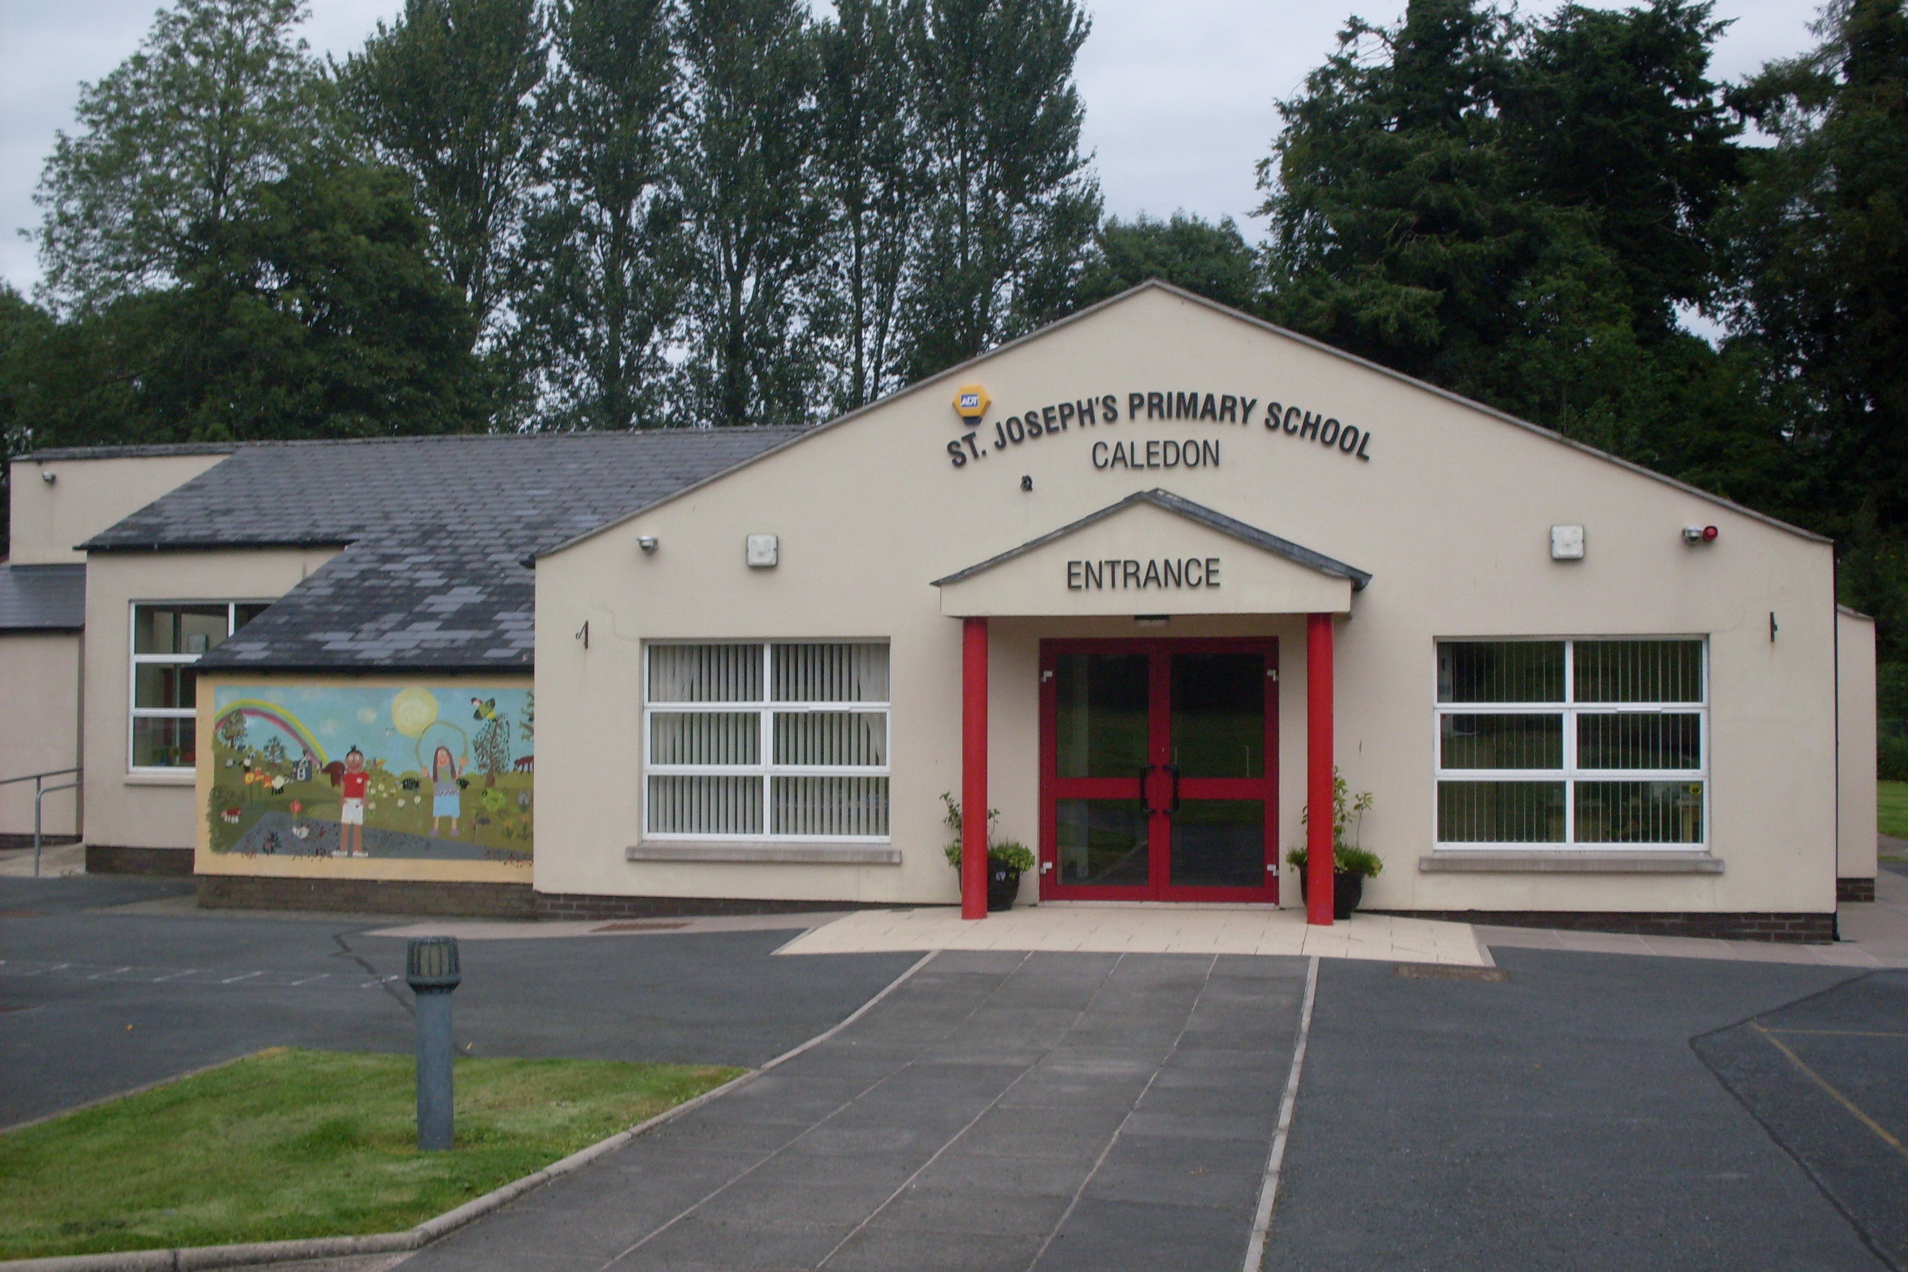

St. Joseph’s Primary School,
14, Derrycourtney Road,
Caledon,
Co. Tyrone
BT68 4UF
Tel: 37568537
Principal: Mrs Marie McKenna

St Joseph’s Primary School

THIS IS A NUT FREE SCHOOL

Newsletter – March 2021

Dear Parents

Dates for the Diary

Date | Event
8th March – 19th March  17th March  2nd – 12th April  12th April | P1- 3 return to school  School closes for St Patrick’s Day  Easter holidays  Staff Training

P1-3 School re-start 8th – 19th March
We are delighted that our P1- P3 children will be back in school on Monday 8th March. Buses and school meals will be available. The P1-2 afterschool club will operate during this period.
The Department of Education support our view that these two weeks will be a time to build relationships, get physically active and to get ready to learn in the school environment again. It will also enable staff to observe and plan the future needs of each child. I am sure you will be delighted to hear that there will be no homework during this period – a much needed break from home-learning

Keyworker & Vulnerable Children
The supervision of keyworker and vulnerable children is an important service and our school has always been open to supervise the learning of these children. However, as the demand increases, we may have to consider allocating slots on a planned basis. This is to ensure we manage numbers in line with our health & safety procedures.
If you wish to avail of this service, you must let us know a week in advance the days you wish to use and we can plan accordingly.

Normal school hours apply:
P1-2 children go home at 1.45pm
P1-3 children go home at 1.45pm on Friday
School will be open from 8.45- 2.45pm for all other children

Please note key worker children will be supervised in the school hall. Staff are continuing to prepare lesson packs for P4-7 children as well as returning to teaching P1-3.
School meals are available from 8th – 19th March . Free school meal children in P4-7 year groups will continue to receive payments directly so ARE NOT entitled to free meals at school.

It is important we have details of your place, hours and days of work.

Miss Largey – Bereavement
I wish to extend to Miss Largey and her family our deepest sympathies on the death of her brother. Miss Largey is in our thoughts and prayers.

Finally, I wish to thank you all for your continued efforts in supporting the learning of your children. Please be assured we are here to help and support in any way we can – just give us a call or message us.
I can only pray that we are ALL back together very soon.

Yours sincerely,
M Mckenna

