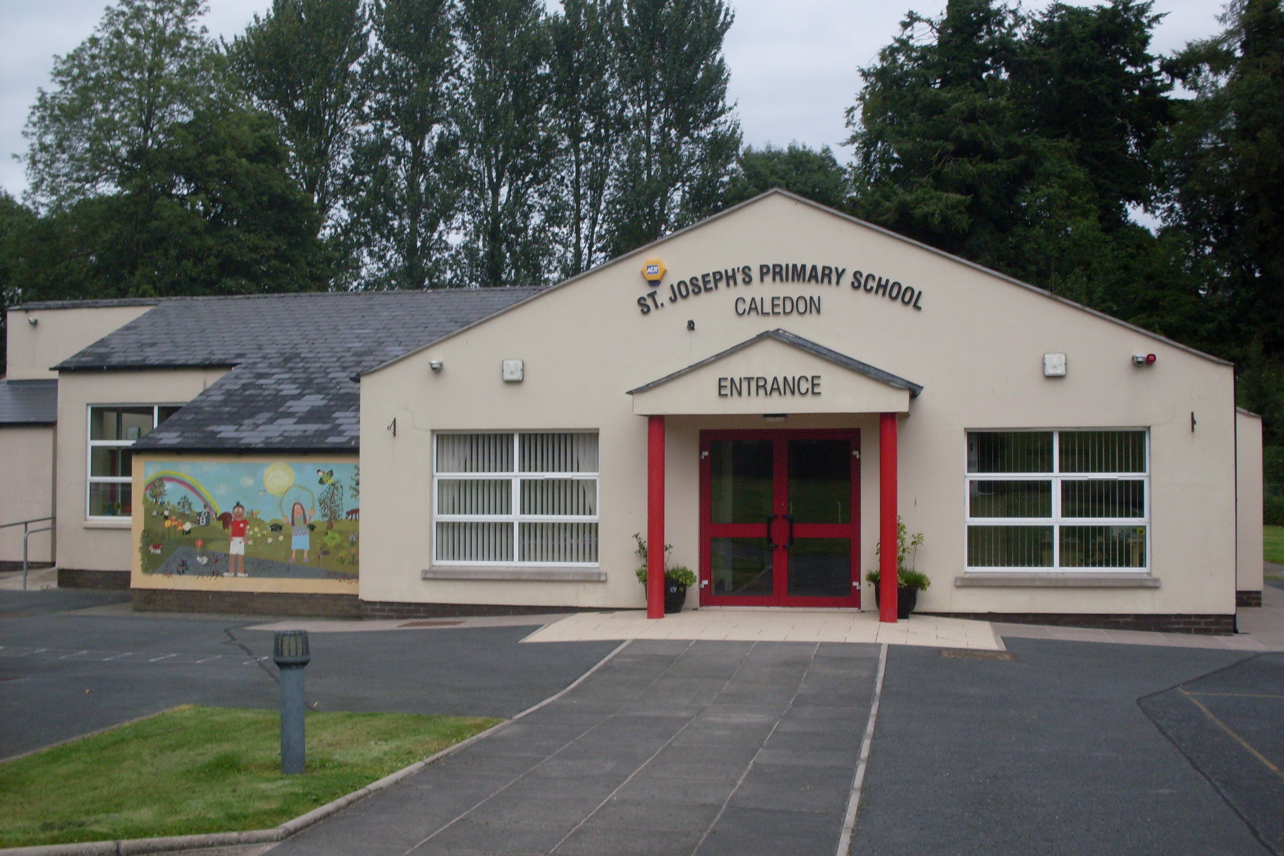

St. Joseph’s Primary School,
14, Derrycourtney Road,
Caledon,
Co. Tyrone
BT68 4UF
Tel: 37568537
Principal: Mrs Marie McKenna

St Joseph’s Primary School

First Holy Communion

Dear Parents

As we near the 17th May, I am sure many of you are thinking about ( with some sadness no doubt!) your child’s First Holy Communion.
It is important for the children to know that this special occasion has been postponed – not cancelled. Although we don’t know when the event will take place, it will be at a time when it is safe to do so.

However, I think it would be nice for the children to know we are still thinking about and praying for them. I would ask that all of the First Holy Communion children post a picture of themselves with a drawing or a colouring sheet showing Jesus and ‘I am the Bread of Life.’ I will post a sheet online if children don’t want to draw.
These can uploaded onto our school website. I will assemble them into a collage and post them on our Facebook page.

Yours sincerely.

M McKenna
Principal

