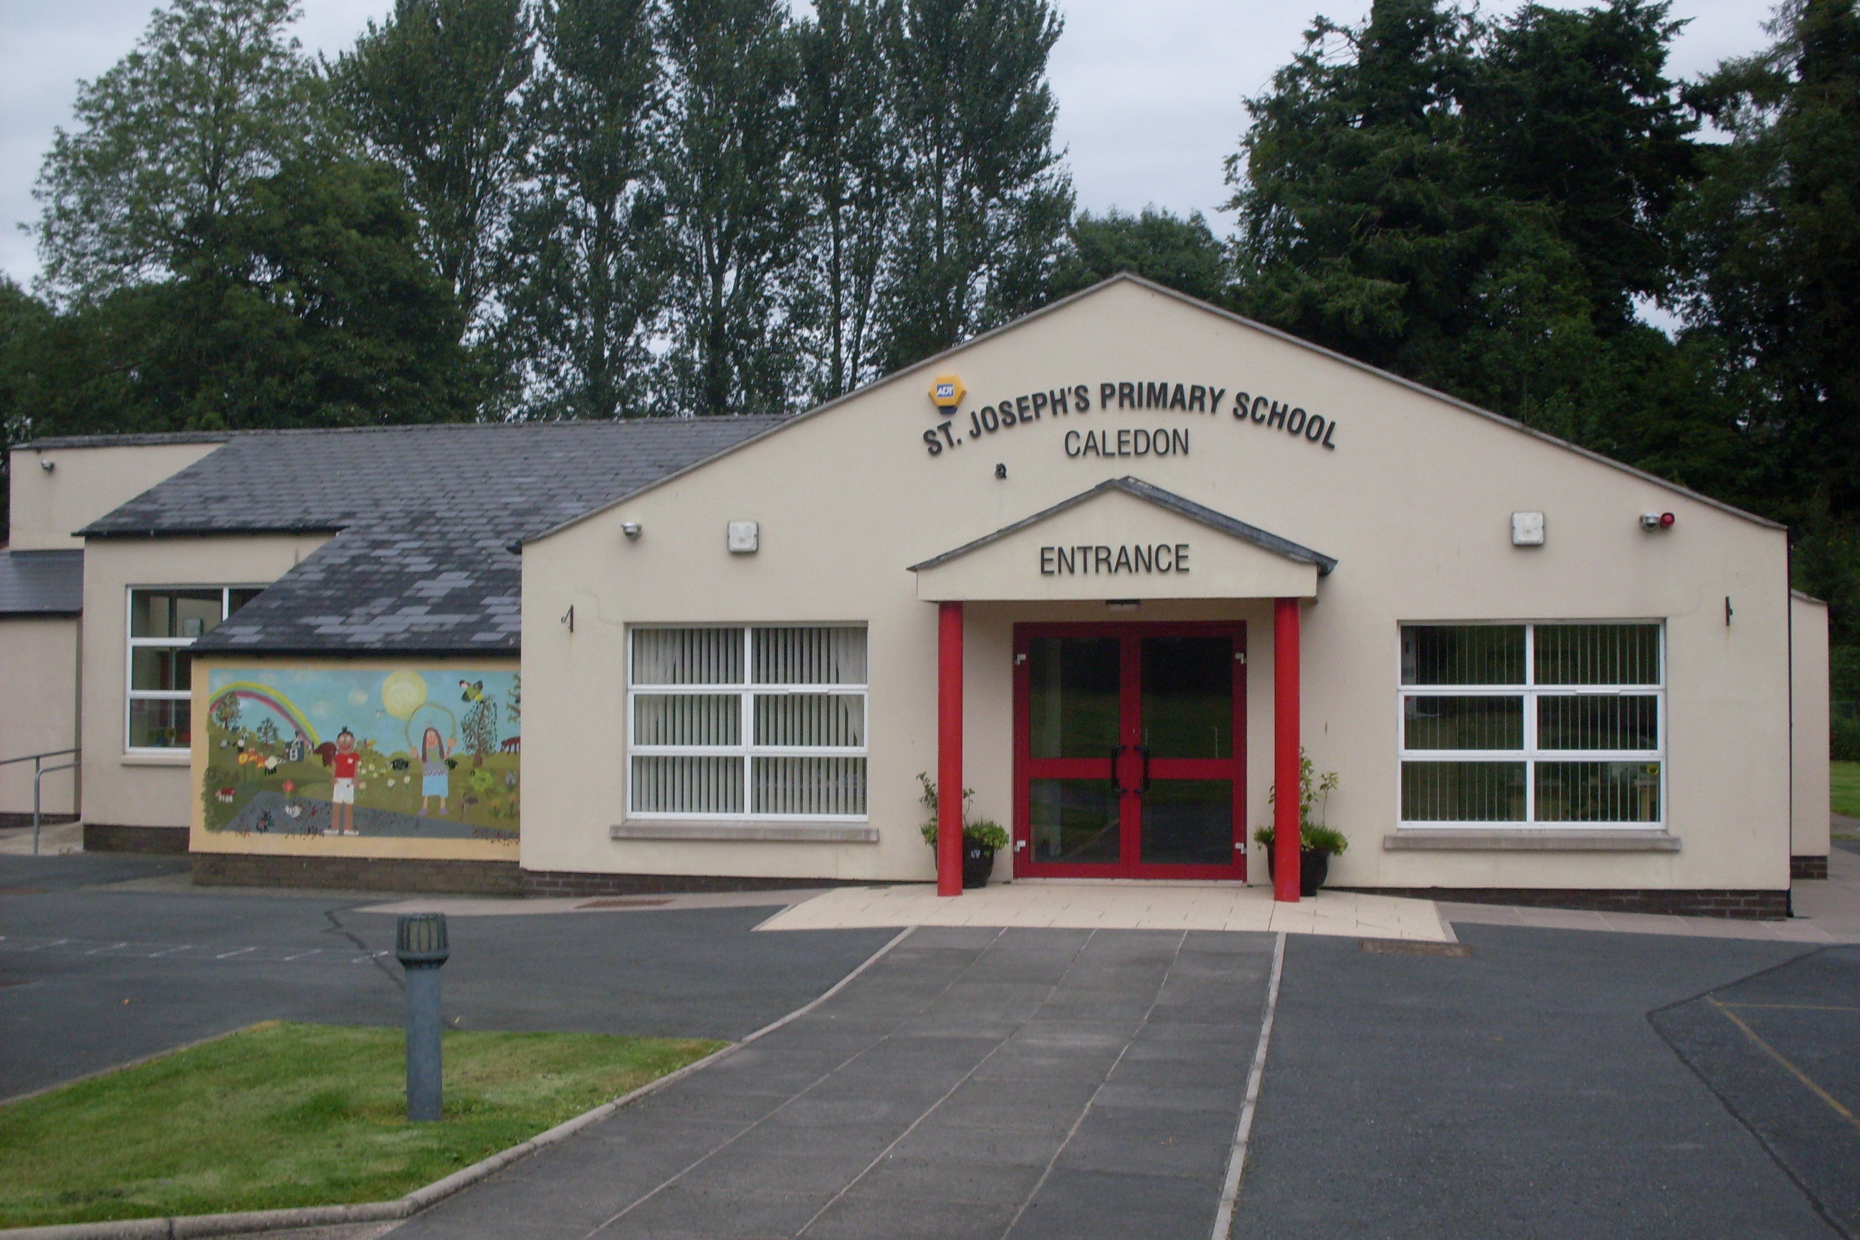

St. Joseph’s Primary School,
14, Derrycourtney Road,
Caledon,
Co. Tyrone
BT68 4UF
Tel: 37568537
Principal: Mrs Marie McKenna

St Joseph’s Primary School

THIS IS A NUT FREE SCHOOL

Newsletter – March 2021(2)

Dear Parents

Dates for the Diary

Date | Event
2nd – 12th April  (school reopens to pupils on Tuesday 13th April)  12th April | Easter holidays  Staff Training

School re-start 22nd March for all pupils
We are delighted that all of our children will be back in school on Monday 22nd March. Buses and school meals will be available. The P1-2 afterschool club will operate during this period.
The Department of Education support our view that these two weeks will be a time to build relationships, get physically active and to get ready to learn in the school environment again. It will also enable staff to observe and plan the future needs of each child. I am sure you will be delighted to hear that there will be no homework during this period – a much needed break from home-learning.
Previous arrangements will apply with some new precautions:
P1-4 will enter and leave via door beside Mrs Mckenna’s room
P5-7 will enter and leave via door behind Miss Largey’s room
These two classes are considered to be two bubbles.
Hand washing and sanitising is freely available and encouraged throughout the school
Parents, wishing to speak with a teacher, must make an appointment and wear a face mask on school premises.
School bags are not needed other than to carry lunches.
PE uniform can be worn – unless otherwise instructed – as we intend to engage in a lot of outdoor activities.
P4- 7 children should bring their learning packs back to school on Monday.

IMPORTANT CHANGE TO PICK- UP ARRANGEMENTS FOR P3-7 AND AFTERSCHOOL CLUB
The Department of Education has impressed upon us the importance of avoiding unnecessary mingling of children and parents at drop off and home- time pick-ups. Thus, from Monday 22nd March, please observe the following:
A member of staff will be at the gate to manage the flow of traffic and ensure only one car is allowed on the premises at any one time. Your child/children can be collected from another member of staff at the path opposite the car park. This may mean that you have to queue at the gate for a short time and we ask that you are patient and understand that we are doing this on advice from the Department of Education.
The same will apply for the early pick-up on Fridays for P1-3
Walkers are not affected but please leave as soon as you have collected your child.
AT NO TIME SHOULD CHILDREN BE ALLOWED TO RUN AROUND THE SCHOOL GROUNDS OR PLAY ON THE SCHOOL EQUIPMENT WITHOUT TEACHER SUPERVISION.
Normal school hours apply:
P1-2 children go home at 1.45pm
P1-3 children go home at 1.45pm on Friday
School will be open from 8.45- 2.45pm for all other children

Easter Holiday Closing
Please note: school is open from 9 am and closes for Easter at 11am on Thursday 1st April. There will be no bus on this day.

Fergal McCann R.I.P.
I wish to extend to our sympathies to the McCann family on the sad passing of Fergal who was a highly regarded and respected football coach at our school. Fergal will be remembered as a patient, kind and professional coach who always wanted the best for all of the children. We were fortunate enough to have Fergal lead our Sports’ Day activities over the last few years. Again his preparation for the event was second to none and he ensured every child participated and had an enjoyable time. Please keep his wife Roisin and two young daughters- Aine and Aoife- in your prayers.

Finally, I wish to thank you all for your continued efforts in supporting the school. This has been a difficult time for many families, some of whom are having to cope with bereavement on top of everything else. But we look forward with hope and optimism for better days ahead.
Yours sincerely,
M Mckenna

